MECHANICS OF SOLIDS
In the course of Engineering Mechanics, we discussed the mechanics of rigid body. There, we were interested only in the effect of forces on the state of the system (whether it is at rest or in motion). We did not consider the deformation caused by the forces on the bodies, and considered them as rigid. Here, we will be considering the system in equilibrium and the effect of the forces on the deformation of the system. A good understanding of the mechanics of solids is very essential in the process of designing of any system.
Stress at a point  Consider a body in equilibrium subjected to different surface forces as shown. Let us consider a section of the body as shown. | P  O  O  T  Q  S
Consider the free-body diagram of one part of the body. For balancing the two external forces acting on the body, a third force must be present. This force need to be generated from the internal forces distributed over the cross sectional area of the body as shown. The intensity of the distributed force is obtained by dividing the force by the area. | R  Q  P  $$∆A$$  P  $$\vec{σ}$$
Consider a point P on the cross section. Let $∆A$ be an infinitesimally small area around the point P. Let $∆F$ be the force acting on this area. The intensity of this internal force is$\frac{∆F}{∆A}$. In the limiting case $∆A→0$, the intensity of internal force $\frac{∆F}{∆A}$ is known as the stress at point P.
$$\vec{σ}=\lim_{∆A→0}{ \frac{∆F}{∆A}}$$
The direction of the stress vector (traction vector) is in the direction of $∆F$ and will be in general inclined to the area. If we consider another cutting plane passing through the same point P, the direction of the stress traction vector at point P will be different. We can consider infinite number of planes passing through point P. The information of stress vectors in all possible planes passing through point P completely defines the state of stress at that point.
We can resolve the stress traction vector in to two components: one normal to the plane we consider and another one parallel to the plane. The normal component is known as normal stress $σ_{n}$ and tangential component is known as shear stress $τ$. If we consider a co-ordinate system in which one axis is normal to the plane, then the shear stress $τ$ can be resolved in to two other components parallel to the other two axes as shown.
Hence, we can resolve any stress vector in to three components: one normal stress and two shear stress components. As we discussed in the beginning, the stress vectors acting on different planes are different. So, it is important to designate the plane on which the stress is being considered. | $$σ_{n} ( or σ_{yy})$$  $$y$$  $$\vec{σ}$$  $$τ_{yx}$$  $$x$$  $$τ_{yz}$$  $$τ$$  $$x$$
When we specify a stress value, it should have a magnitude, a direction, and the plane information. A plane is designated by its direction of outward normal. Generally, a stress is specified as $σ_{ij},$where $i$ represents the direction of outward normal to the plane and $j$is the direction of the stress. The plane in the above figure has an outward normal in the y-direction. So, the normal stress in the y-direction acting on a plane whose outward normal is in the y direction is designated as $σ_{yy}$. Similarly, the shear stresses acting along the x and z directions on the plane whose normal is in the y direction are designated as $σ_{yx}$ and $σ_{yz}$ ($or τ_{yx}$ and $τ_{yz}$). We need two indices to represent a stress; one for the plane and one for the direction. Stresses are considered as second order tensors.

Sign convention: The stresses are considered positive if it is acting on a positive plane (whose outward normal is in the positive co-ordinate direction) in the positive co-ordinate direction or on a negative plane in the negative co-ordinate direction. Otherwise, it is considered as negative.

It was already mentioned before that to describe the state of stress at any point in the body, we need to know the stress information in all the possible planes passing through that point. But, we can prove that if we know the stresses in three mutually perpendicular planes passing through a point, stresses in any other plane passing through that point can be found out.
$$z$$

$$τ_{yx}$$
$$σ_{yy}$$
$$y$$

$$τ_{yz}$$
$$O$$

$$A$$

$$B$$

$$C$$

$$O$$

$$C$$

$$A$$

$$x$$

$$n$$

$${\vec{T}}_{z}$$

$${\vec{T}}_{y}$$
$$O$$

$$A$$

$$τ_{zx}$$
$$σ_{zz}$$
$$τ_{zy}$$
$$B$$

$$\vec{T}$$
$$τ_{xy}$$
$$σ_{xx}$$
$$τ_{xz}$$
$$O$$

$$A$$

$$B$$

$${\vec{T}}_{x}$$

Consider a co-ordinate system passing through a point $O$ as shown. Let $ABC$ be any plane inclined to all the co-ordinate axes so that $OABC$ is a tetrahedron with a very small altitude $h$. We can imagine that this tetrahedron is cut out from a body subjected to forces and in equilibrium. Let $n$ be the direction of the outward normal to the plane $ABC$. Consider that $n_{x}$, $n_{y}, n_{z}$ be that the direction cosines of the normal.
That is, $n_{x}=\cos\left(n,x\right), n_{y}=\cos\left(n,y\right), n_{z}=\cos\left(n,z\right)$. $OAB, OBC,$ and $OCA$ are three mutually perpendicular planes passing through point $O$. Let $A$ be the area of the plane $ABC$. Then area $OAC$ is the projection of $ABC$ on to the $x-z$ plane. If $θ$ is the angle between the plane $ABC$ and plane $x-z$, then angle between their normal $n$ and $y$ is also equal to $θ$
Area $OAC$= Area $ABC$ $×\cos{θ}=A× n_{y}$
Similarly, area $OAB$ $=A× n_{z}$
Area $OBC$ $=A× n_{x}$
Let $\vec{T}$ be the stress vector on plane $ABC$. Let ${\vec{T}}_{x}$, ${\vec{T}}_{y},$and ${\vec{T}}_{z}$ be the components of this vector along the co-ordinate directions. Since, it is cut out from a body in equilibrium, this tetrahedron also will be in equilibrium. Since the area of plane $ABC$ is $A$,
the forces on plane $ABC$ in x-y-z directions are ${\vec{T}}_{x}×A$, ${\vec{T}}_{y}×A,$and ${\vec{T}}_{z} ×A$
the forces on plane $OAC$ in x-y-z directions are $τ_{yx}× An_{y}$, $σ_{yy}× An_{y}$, and $τ_{yz}× An_{y}$
the forces on plane $OAB$ in x-y-z directions are $τ_{zx}× An_{z}$, $τ_{zy}× An_{z}$, and $σ_{zz}× An_{z}$
the forces on plane $OBC$ in x-y-z directions are $σ_{xx}× An_{x}$, $τ_{xy}× An_{x}$, and $τ_{xz}× An_{x}$
For equilibrium, $ΣF_{x}=0$ $≫≫ {\vec{T}}_{x}×A-σ_{xx}× An_{x}-τ_{yx}× An_{y}-τ_{zx}× An_{z}=0$
$$ΣF_{y}=0≫≫ {{\vec{T}}_{y}×A}_{ }-τ_{xy}× An_{x}- σ_{yy}× An_{y}-τ_{zy}× An_{z}=0$$
$$ΣF_{z}=0≫≫ {\vec{T}}_{z} ×A-τ_{xz}× An_{x}- τ_{yz}× An_{y}-σ_{zz}× An_{z}=0$$
$${\vec{T}}_{x}=σ_{xx}n_{x}+τ_{yx}n_{y}+τ_{zx}n_{z}$$  $${{\vec{T}}_{y}=}_{ }τ_{xy}n_{x}+σ_{yy}n_{y}+τ_{zy}n_{z}$$  $${\vec{T}}_{z}=τ_{xz}n_{x}+τ_{xy}n_{y}+σ_{zz}n_{z}$$  Cauchy’s stress formula  $$T_{i}=σ_{ij}n_{j}$$  $$\left[\begin{matrix}{\vec{T}}_{x} \\ {\vec{T}}_{y} \\ {\vec{T}}_{z}\end{matrix}\right]=\left[\begin{matrix}σ_{xx} & τ_{yx} & τ_{zx} \\ τ_{xy} & σ_{yy} & τ_{zy} \\ τ_{xz} & τ_{yz} & σ_{zz}\end{matrix}\right]\left\{\begin{matrix}n_{x} \\ n_{y} \\ n_{z}\end{matrix}\right\}$$  $$\left[T\right]=\left[σ\right]\left\{n\right\}$$ | $$T=\sqrt{{T_{x}}^{2}+{T_{y}}^{2}+{T_{z}}^{2}}$$ | Normal stress on the plane ABC,  $T^{n}=T_{x} n_{x}+T_{y} n_{y}+T_{z} n_{z}$  $$T^{n}=\left(σ_{xx}n_{x}+τ_{yx}n_{y}+τ_{zx}n_{z}\right)n_{x}+$$  $\left(τ_{xy}n_{x}+σ_{yy}n_{y}+τ_{zy}n_{z}\right)n_{y}+$  $$(τ_{xz}n_{x}+ τn_{y}+σ_{zz}n_{z}) n_{z}$$  $$T^{n}=σ_{ij}n_{i}n_{j}$$  $$\left[T^{n}\right]={\left\{n\right\}}^{T}\left[σ\right]\left\{n\right\}$$  Shear stress on the plane ABC,  $$τ=\sqrt{T^{2}-{T^{n}}^{2}}$$

In the limit $h→0$, the plane ABC passes through point O. That is, if we know the stress components in three mutually perpendicular planes passing through a point, we can determine the stress components in any other plane passing through that point and having direction cosines ($n_{x}$, $n_{y}, n_{z})$.
Hence, if we know the stress components in three mutually perpendicular planes passing through a point, the state of stress at that point is completely defined.
i.e., the stress tensor matrix $σ_{ij}=\left[\begin{matrix}σ_{xx} & τ_{yx} & τ_{zx} \\ τ_{xy} & σ_{yy} & τ_{zy} \\ τ_{xz} & τ_{yz} & σ_{zz}\end{matrix}\right]$ completely defines the state of stress at a point.

Consider that from around any point on the stressed material, an infinitesimally small parallelepiped of dimensions $∆x$, $∆y$, and $∆z$ cut out. In the limit when $∆x$, $∆y$, and $∆z$ tend to zero, the parallele piped converges to three mutually perpendicular planes passing through that point. | $$z$$  $$y$$  $$τ_{zx}$$  $$σ_{zz}$$  $$τ_{zy}$$  $$σ_{xx}$$  $$τ_{xz}$$  $$τ_{xy}$$  $$τ_{yx}$$  $$σ_{yy}$$  $$τ_{yz}$$  $$x$$  $$σ_{yy}$$  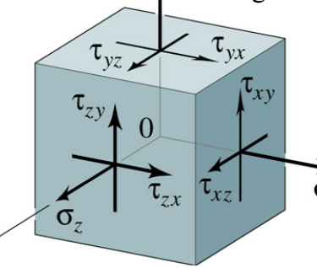  $$σ_{xx}$$
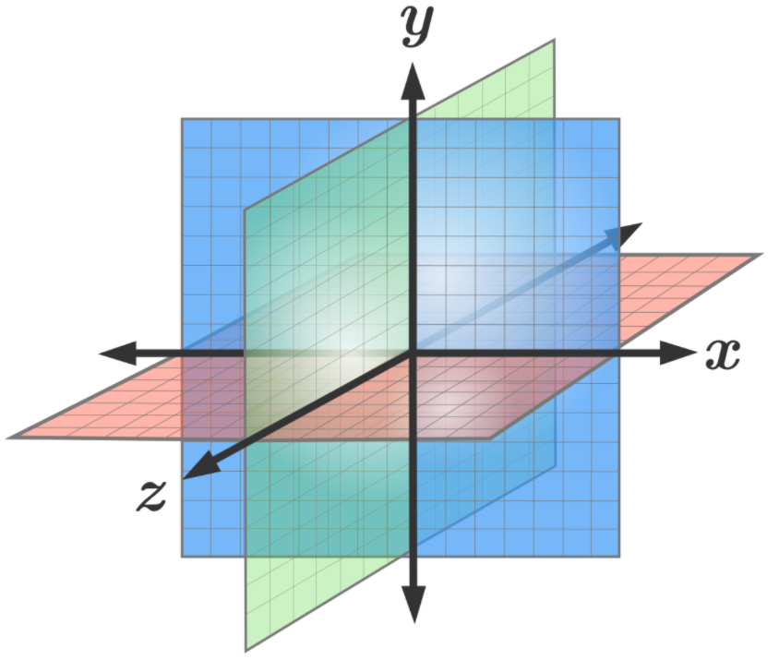

Though the stresses on adjacent parallel faces are shown as the same in the figure, in realaity, they vary continously over the body. Here, that variation is neglected. The forces are balanced in the x-y-z directions. For equilibrium, the moments of the forces must also be balanced.
$$ΣM_{z}=0≫≫≫ {(τ}_{xy} ∆y ∆z )∆x-{(τ}_{yx} ∆x ∆z )∆y=0≫≫ τ_{xy}=τ_{yx}$$
$$ΣM_{x}=0≫≫≫ {(τ}_{yz} ∆x ∆z )∆y-{(τ}_{zy} ∆x ∆y )∆z=0≫≫ τ_{yz}=τ_{zy}$$
$$ΣM_{y}=0≫≫≫ {(τ}_{xz} ∆y ∆z )∆x-{(τ}_{zx} ∆x ∆y )∆z=0≫≫ τ_{zx}=τ_{xz}$$

The stress tensor matrix is symmetric matrix. The state of stress at a point in a deformed body can be completely defined by the six components of stresses in three mutually perpendicular planes.
$$σ_{ij}=\left[\begin{matrix}σ_{xx} & τ_{xy} & τ_{xz} \\ τ_{yx} & σ_{yy} & τ_{yz} \\ τ_{zx} & τ_{zy} & σ_{zz}\end{matrix}\right]$$

